Apple store

Web technologies

**Description:**

This web application will be used to sell phones, tablets, laptops. User needs to be signed in to the system to make an order. Each user will have basket and ability to pick products on it. After decision is made user can proceed to complete purchasing.

**Components:**

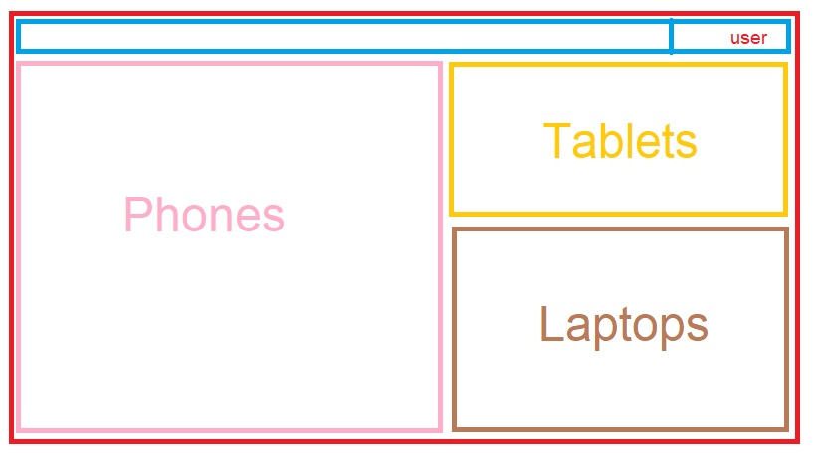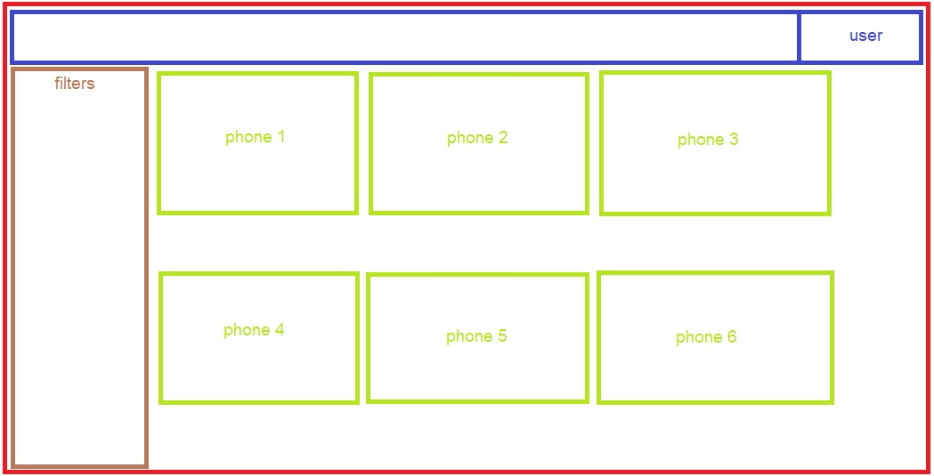

UML(diagram):

